Report on dup and dup2() System Calls
In our shell program, we use dup2() system call to handle pipelines. dup and dup2 are used to duplicate file descriptors, which helps in redirecting input and output of processes.

1. dup() system call
dup() makes a copy of an existing file descriptor and returns a new one.
Both file descriptors point to the same open file description.
Figure 1: Working of dup() system call
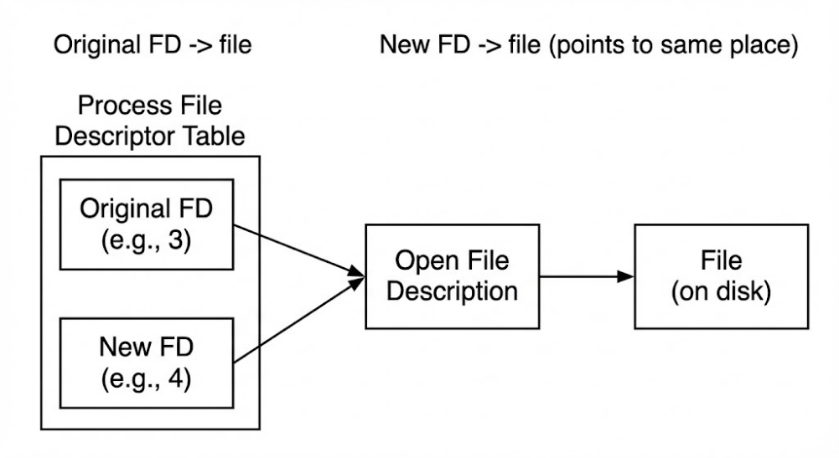
In this figure, the original file descriptor and the new file descriptor both refer to the same open file. Any read or write using either descriptor affects the same file.

2. dup2() system call
dup2(oldfd, newfd) copies oldfd to newfd.
If newfd is already open, it is closed first. This is very useful for redirecting standard input and output.
Figure 2: Unix pipeline connection using dup2()
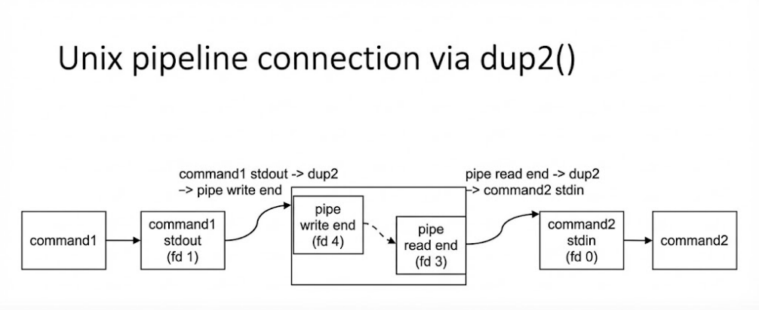
This figure shows how output of one command is sent to the next command using pipes and dup2().

3. Use of dup2() in shell
In a pipeline, one command produces output and the next command uses that output as input.
dup2() is used to redirect stdout of one command to the pipe and stdin of the next command from the pipe.
This allows commands like ls | wc to work correctly.

That’s all.

